Section 1: Head and neck

Card ID: 1.1
Image file: L1344_760012
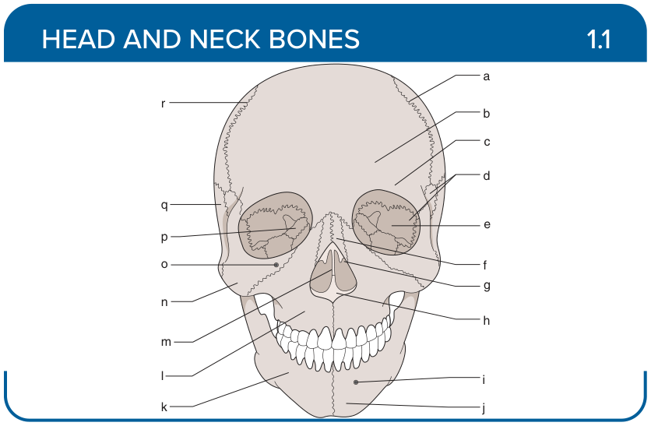
Title: Gross Anatomy
Activity Interaction: Drag and Drop
Back-of-Card Content:
a. Parietal bone
b. Frontal bone
c. Supraorbital ridge
d. Sphenoid bone
e. Orbit
f. Nasal bone
g. Nasal concha
h. Vomer
i. Mental foramen
j. Mental protuberance
k. Mandible
l. Maxilla
m. Septum
n. Zygomatic bone
o. Infraorbital foramen
p. Ethmoid bone
q. Temporal bone
r. Coronal suture

Card ID: 1.2
Image file: L1344_760013
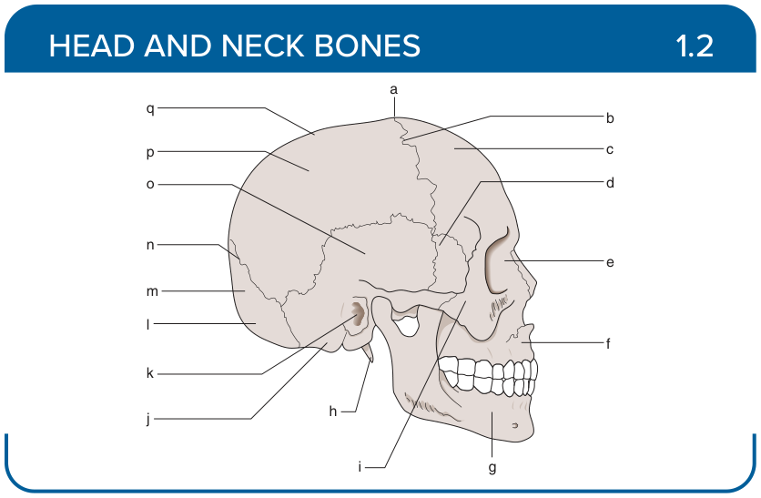
Title: Skull (Lateral)
Activity Interaction: Drag and Drop
Back-of-Card Content:
a. Suture
b. Coronal suture
c. Frontal bone
d. Sphenoid bone
e. Lacrimal bone
f. Maxilla
g. Mandible
h. Styloid process
i. Zygomatic arch
j. Mastoid process
k. External acoustic meatus
l. External occipital protuberance
m. Occipital bone
n. Lambdoidal suture
o. Temporal bone
p. Parietal bone
q. Sagittal suture

Card ID: 1.3
Image file: L1344_760014
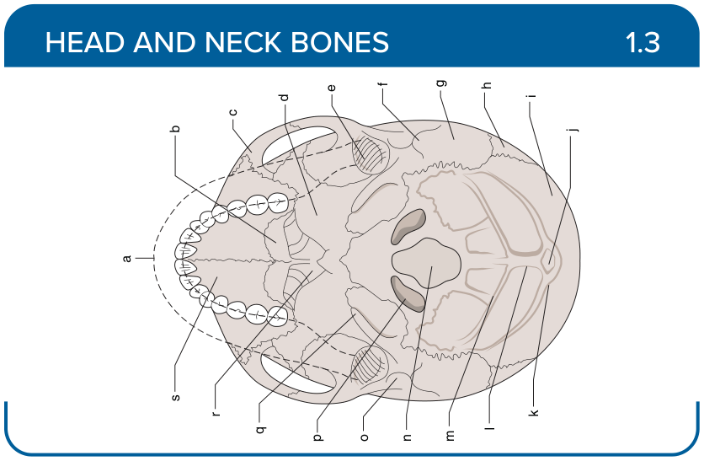
Title: Skull (Inferior)
Activity Interaction: Drag and Drop
Back-of-Card Content:
a. Outline of the mandible
b. Palatine bone
c. Zygomatic bone
d. Sphenoid bone
e. Mandibular fossa
f. Mastoid process
g. Temporal bone
h. Parietal bone
i. Occipital bone
j. External occipital protuberance
k. Superior nuchal line
l. External occipital crest
m. Inferior nuchal line
n. Foramen magnum
o. External acoustic meatus
p. Occipital condyle
q. Styloid process
r. Vomer
s. Maxilla

Card ID: 1.4
Image file: L1344_760015
Activity Interaction: Drag and Drop
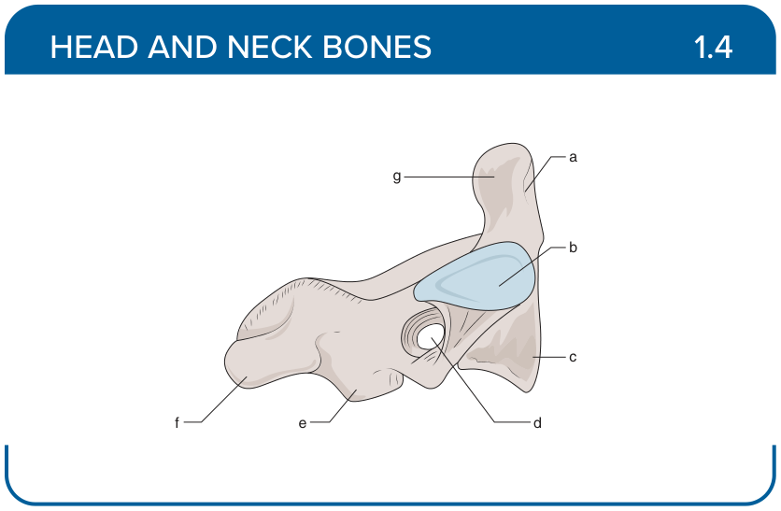
Title: Vertebral Column (Posterior)
Back-of-Card Content:
a. Facet of dens
b. Superior articular facet
c. Body
d. Transverse foramen
e. Inferior articular process
f. Spine
g. Dens

Card ID: 1.5
Image file: L1344_760016
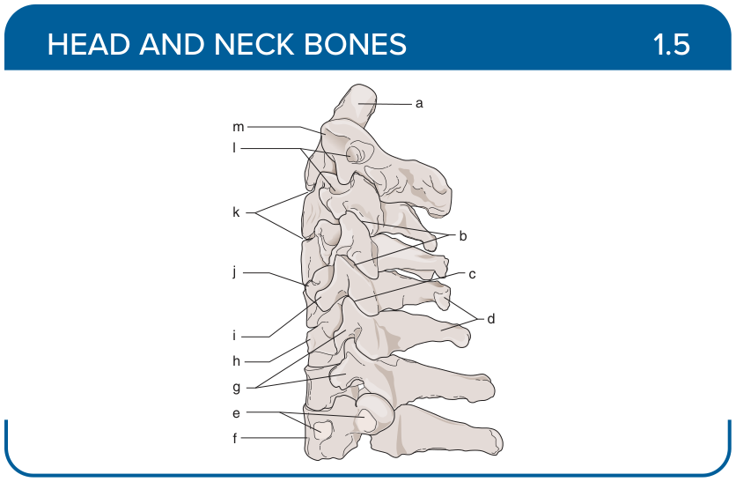
Title: Vertebral Column (Lateral)
Activity Interaction: Drag and Drop
Back-of-Card Content:
a. Dens
b. Zygapophyseal joints
c. Intervertebral disc (not shown)
d. Spinous processes
e. Costal facets (for first rib)
f. T1
g. Articular pillar formed by articular processes
h. C6
i. Posterior tubercle
j. Anterior tubercle
k. Intervertebral joints (symphysis) (disc removed)
l. Intervertebral foramina
m. C2

Card ID: 1.6
Image file: L1344_760017
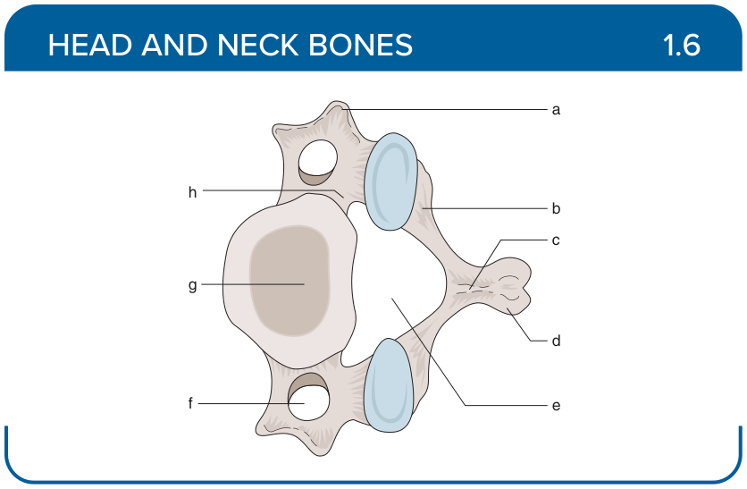
Title: Vertebra (Superior)
Activity Interaction: Drag and Drop
Back-of-Card Content:
a. Transverse process
b. Lamina
c. Neural arch
d. Spinous process
e. Vertebral foramen
f. Transverse foramen
g. Vertebral body
h. Pedicle

Card ID: 1.7
Image file: L1344_760018
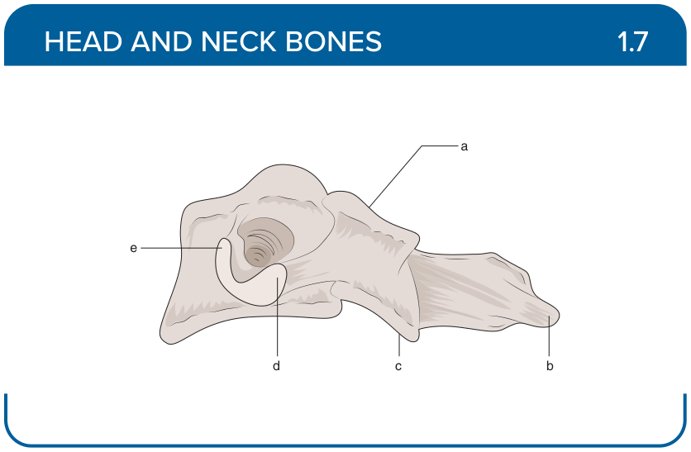
Title: Vertebra (Lateral)
Activity Interaction: Drag and Drop
Back-of-Card Content:
a. Superior articular facet
b. Spinous process
c. Inferior articular facet
d. Posterior tubercle
e. Anterior tubercle

Card ID: 1.8
Image file: L1344_760019
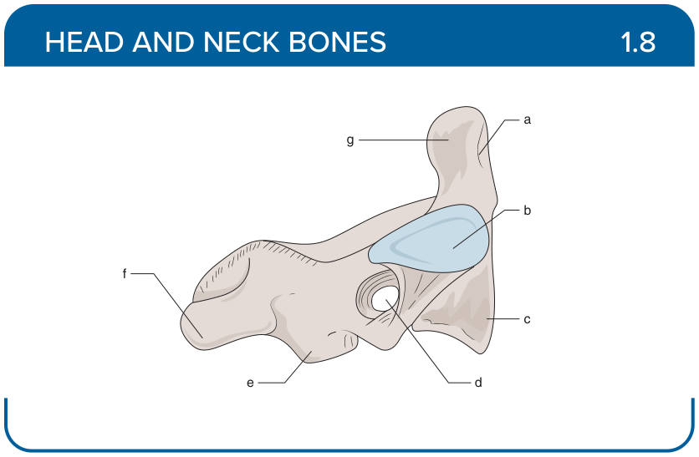
Title: Vertebra (C2 Lateral)
Activity Interaction: Drag and Drop
Back-of-Card Content:
a. Facet on dens
b. Superior articular facet
c. Body
d. Transverse foramen
e. Inferior articular process
f. Spine
g. Dens

Card ID: 1.9
Image file: L1344_760020
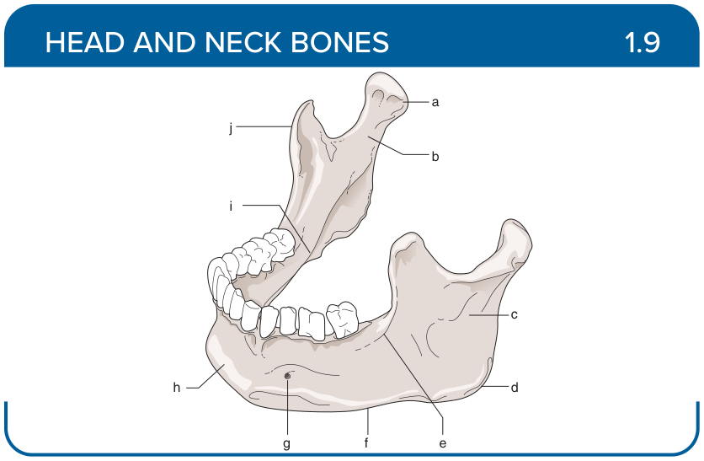
Title: Mandible
Activity Interaction: Drag and Drop
Back-of-Card Content:
a. Mandibular condyle
b. Neck
c. Ramus
d. Angle
e. Oblique line
f. Body
g. Mental foramen
h. Mental protuberance
i. Mylohyoid line
j. Coronoid process

Card ID: 1.10
Image file: L1344_760021
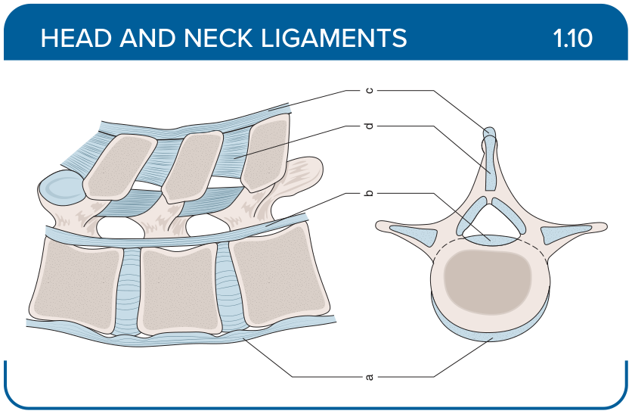
Title: Vertebral Ligaments
Activity Interaction: fill-in-the-blank
Back-of-Card Content:
a. Ligamentum flavum: restricts excessive separation of adjacent vertebral lamina and hyperflexion
b. Anterior longitudinal ligament: restricts excessive hyperextension
c. Posterior longitudinal ligament: restricts hyperflexion
d. Supraspinous ligament: restricts hyperflexion; also prevents separation of the spinous processes
e. Interspinous ligament: restricts hyperflexion

Card ID: 1.11
Image file: L1344_760022
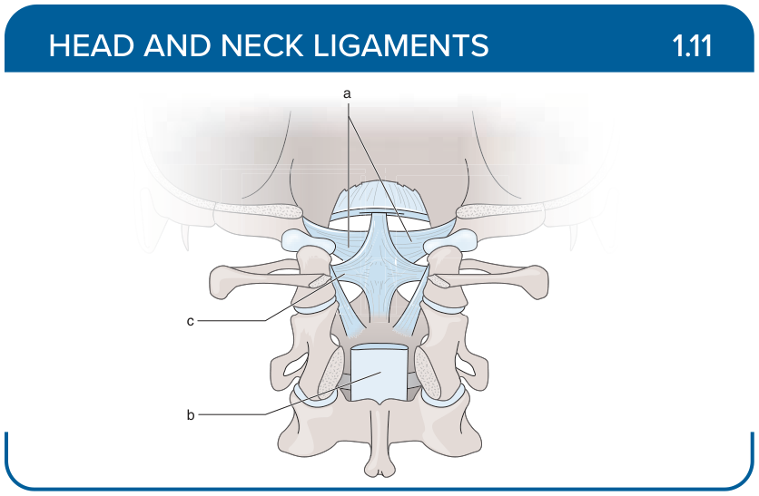
Title: Posterior Ligaments
Activity Interaction: fill-in-the-blank
Back-of-Card Content:
a. Alar ligaments: restricts excessive rotation and lateral flexion
b. Posterior longitudinal ligament: restricts hyperflexion
c. Cruciform ligament (transverse + longitudinal bands): restricts abnormal movements of atlantoaxial joint (hyperflexion, hyperextension)

Card ID: 1.12
Image file: L1344_760023
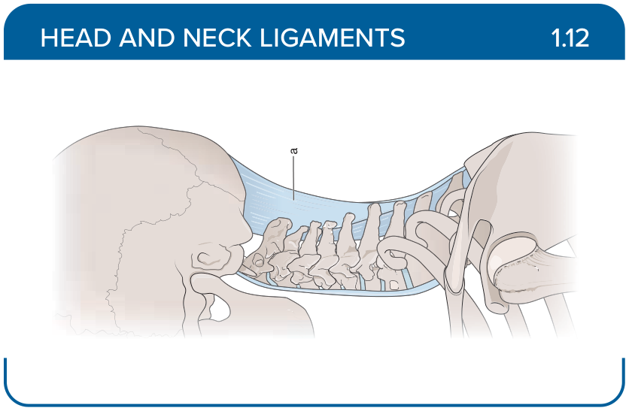
Title: Craniospinal Junction
Activity Interaction: fill-in-the-blank
Back-of-Card Content:
Nuchal ligament: restricts hyperflexion

Card ID: 1.13
Image file: L1344_760024
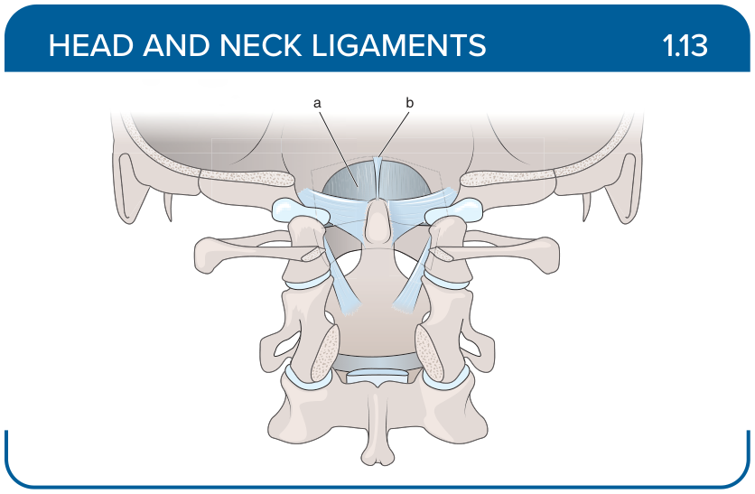
Title: Atlas and Axis Ligaments
Activity Interaction: fill-in-the-blank
Back-of-Card Content:
a. Anterior atlanto-occipital ligament: restricts extension of the head
b. Apical ligament of the dens: restricts destabilization of the dens, therefore supporting the craniocervical joint

Card ID: 1.14
Image file: L1344_760025
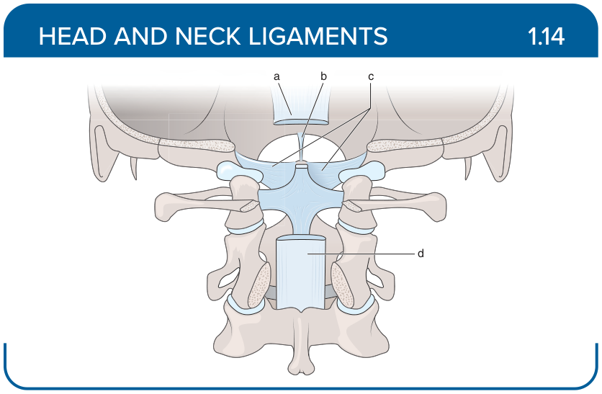
Title: Head and Neck
Activity Interaction: fill-in-the-blank
Back-of-Card Content:
a. Tectorial membrane: restricts anterior displacement of C1 over C2
b. Apical ligament of the dens: restricts destabilization of the dens, therefore supporting the craniocervical joint
c. Alar ligaments: restricts excessive rotation and lateral flexion
d. Posterior longitudinal ligament: restricts hyperflexion

Card ID: 1.15
Image file: L1344_760026
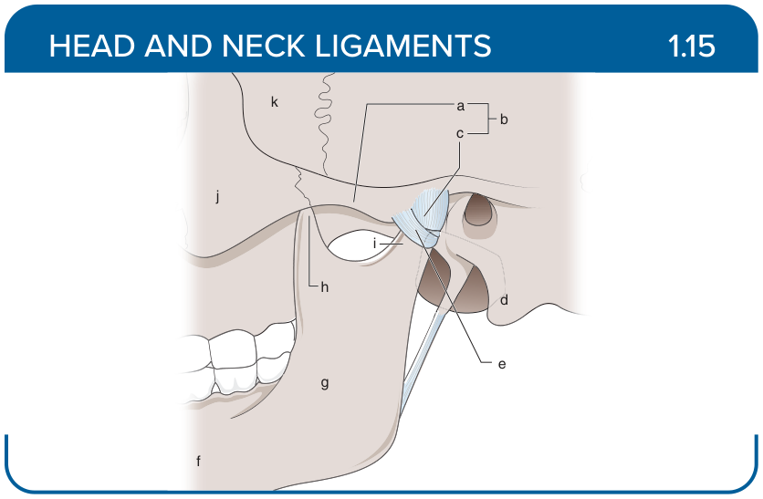
Title: Temporomandibular Joint
Activity Interaction: Drag and Drop
Back-of-Card Content:
a. Zygomatic process
b. Temporal bone
c. Temporomandibular joint
d. Mastoid process
e. Condyloid process
f. Mandible
g. Ramus
h. Coronoid process
i. Neck
j. Zygomatic bone
k. Sphenoid bone

Card ID: 1.16
Image file: L1344_760027
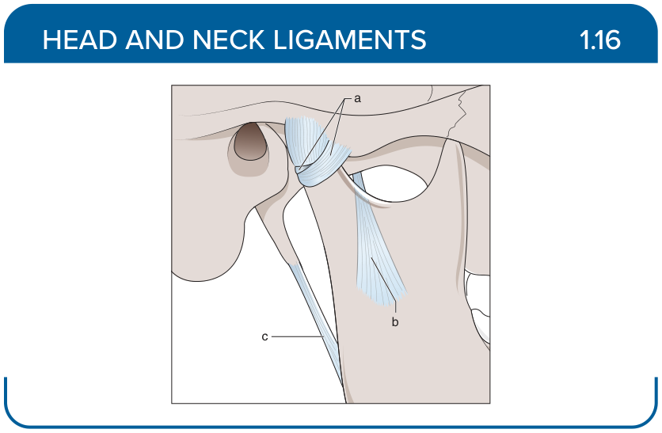
Title: Temporomandibular Ligaments
Activity Interaction: fill-in-the-blank

Back-of-Card Content:
a. Lateral (temporomandibular) ligament: restricts posterior displacement of mandible and helps to stabilize TMJ
b. Sphenomandibular ligament: restricts inferior distension of the mandible
c. Stylomandibular ligament: restricts excessive anterior translation of the temporomandibular joint, thereby limiting mouth opening

Card ID: 1.17
Image file: L1344_760028
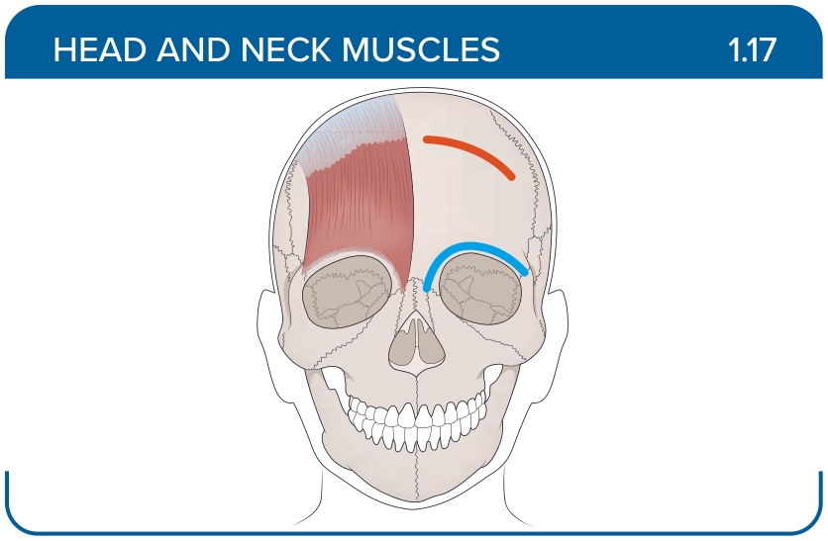
Title: Frontalis
Activity Interaction: Select all that apply
Back-of-Card Content:
Proximal insertion:
a.*epicranial aponeurosis
b. pectoral fascia
c. nasal part of the frontal bone
Distal insertion:
- *skin of the eyebrows and root of the nose
- superior nuchal line of the occipital bone
- parotid fascia
Innervation:
- *facial
- CN XII
- accessory nerve (CN XI)
Action:
a. *raises eyebrows
b. *wrinkles forehead
c. tenses skin of the neck
d. closes eyelids

Card ID: 1.18
Image file: L1344_760029
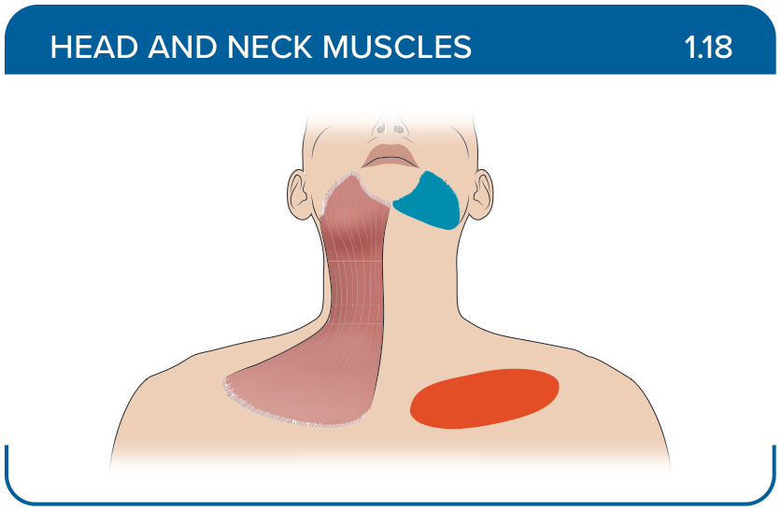
Title: Platysma
Activity Interaction: Select all that apply
Back-of-Card Content:
Proximal insertion:
- *pectoral fascia
- medial aspects of the maxilla and mandible
- anterior surface of the manubrium of the sternum

Distal insertion:
- *inferior border of the mandible and adjacent muscles
- lateral surface of the zygomatic bone
- mastoid process of the temporal bone
Innervation:
- *facial
- CN XII
- accessory nerve (CN XI)

Action:
a. *tenses skin of the neck
b. *depresses mandible
c. compresses cheeks
d. pulls angle of the mouth laterally

Card ID: 1.19
Image file: L1344_760030
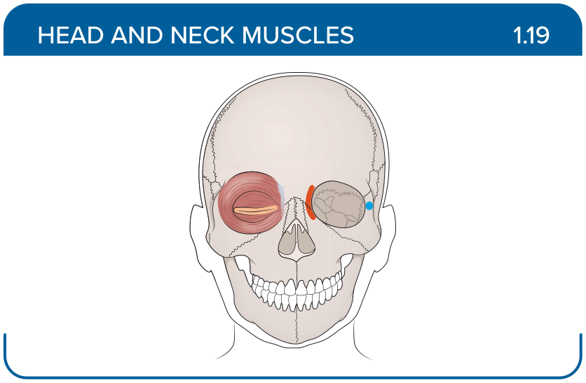
Title: Orbicularis oculi
Activity Interaction: Select all that apply
Back-of-Card Content:
Proximal insertion:
- *nasal part of the frontal bone
- *frontal process of the maxilla
- *medial palpebral ligament
- *posterior lacrimal crest of the lacrimal bone

Distal insertion:
- *lateral palpebral raphe
- *overlying subcutaneous tissue
- lateral surface of the zygomatic bone
- infraorbital margin

Innervation:
- *facial
- CN XII
- accessory nerve (CN XI)

Action:
- *closes eyelids
- *compresses lacrimal sac
- depresses eyebrows

Card ID: 1.20
Image file: L1344_760031
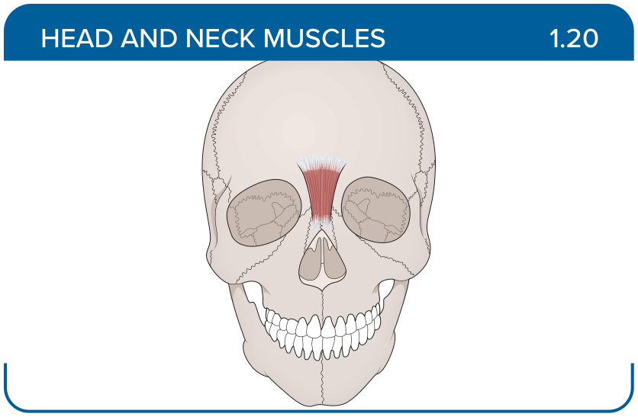
Title: Procerus
Activity Interaction: Select all that apply
Back-of-Card Content:
Proximal insertion:
- *nasal bone
- medial aspects of the maxilla
- lateral surface of the zygomatic bone
- incisive fossa of the mandible

Distal insertion:
- *skin of the lower medial forehead
- subcutaneous tissue of the chin
- oblique line of the mandible

Innervation:
- *facial
- CN XII
- accessory nerve (CN XI)

Action:
- *depresses eyebrows
- tenses skin of the neck
- depresses angle of the mouth

Card ID: 1.21
Image file: L1344_760032
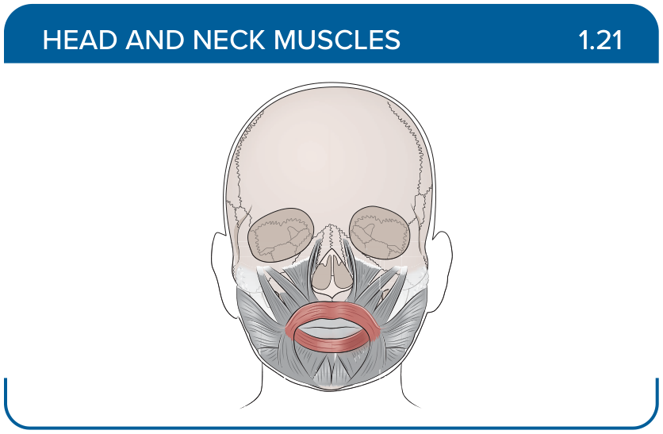
Title: Orbicularis oris
Activity Interaction: Select all that apply
Back-of-Card Content:
Proximal insertion:
- *medial aspects of the maxilla and mandible
- *perioral skin and muscles
- *modiolus

Distal insertion:
- *skin and mucous membrane of the lips
- angle of the mouth
- subcutaneous tissue of the chin

Innervation:
- *facial
- CN XII
- accessory nerve (CN XI)

Action:
- *closes mouth
- *compresses and protrudes lips
- elevates and everts upper lip
- elevates angle of the mouth

Card ID: 1.22
Image file: L1344_760033
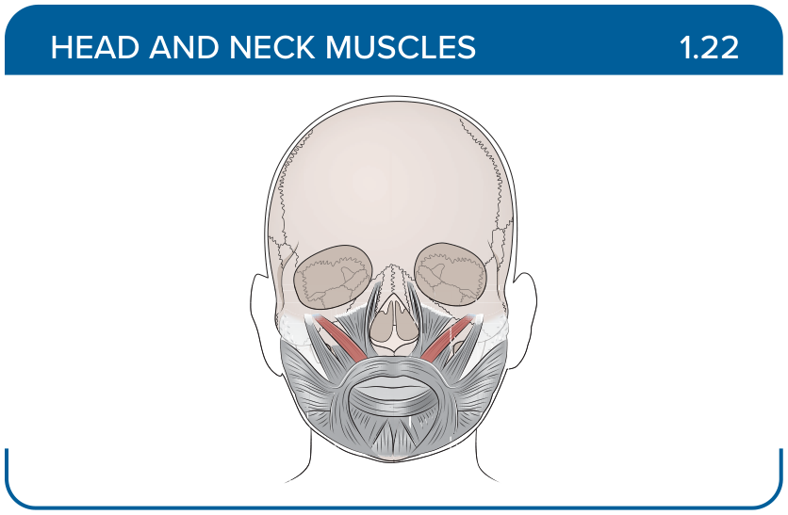
Title: Zygomaticus minor
Activity Interaction: Select all that apply
Back-of-Card Content:
Proximal insertion:
- *lateral surface of the zygomatic bone
- medial aspects of the maxilla
- medial aspects of the mandible

Distal insertion:
- *angle of the mouth
- skin and mucous membrane of the lips
- infraorbital margin

Innervation:
- *facial
- CN XII
- accessory nerve (CN XI)

Action:
- *elevates upper lip
- closes mouth
- compresses and protrudes lips
- elevates angle of the mouth

Card ID: 1.23
Image file: L1344_760034
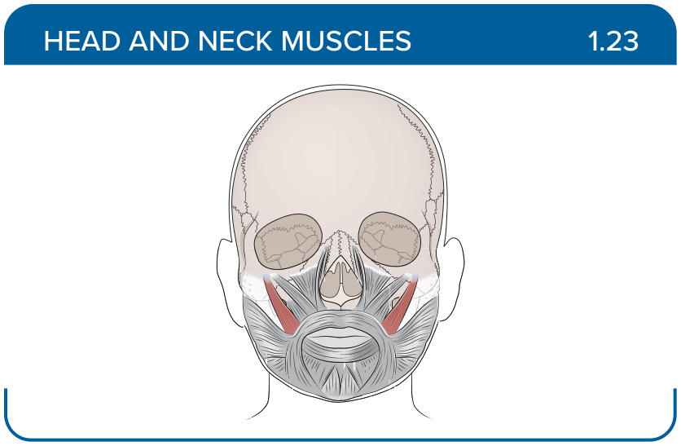
Title: Zygomaticus major
Activity Interaction: Select all that apply
Back-of-Card Content:
Proximal insertion:
- *lateral surface of the zygomatic bone
- medial aspects of the maxilla
- medial aspects of the mandible

Distal insertion:
- *angle of the mouth
- skin and mucous membrane of the lips
- infraorbital margin

Innervation:
- *facial
- CN XII
- accessory nerve (CN XI)

Action:
- elevates upper lip
- closes mouth
- compresses and protrudes lips
- *elevates angle of the mouth

Card ID: 1.24
Image file: L1344_760035
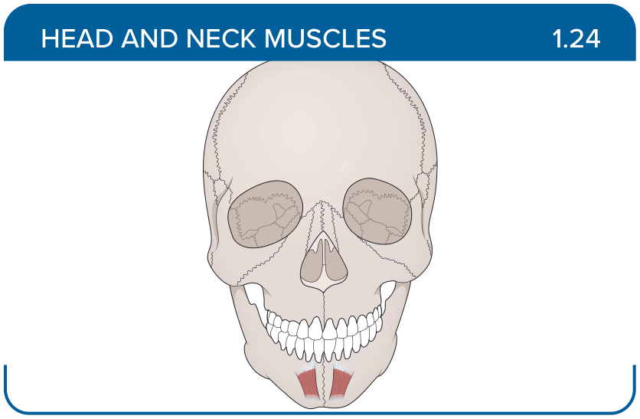
Title: Mentalis
Activity Interaction: Select all that apply
Back-of-Card Content:
Proximal insertion:
- *incisive fossa of the mandible
- medial aspects of the maxilla and mandible
- perioral skin and muscles

Distal insertion:
- *subcutaneous tissue of the chin
- skin and mucous membrane of the lips
- infraorbital margin

Innervation:
- *facial
- CN XII
- accessory nerve (CN XI)

Action:
- *elevates and protrudes lower lip
- closes mouth
- compresses and protrudes lips

Card ID: 1.25
Image file: L1344_760036
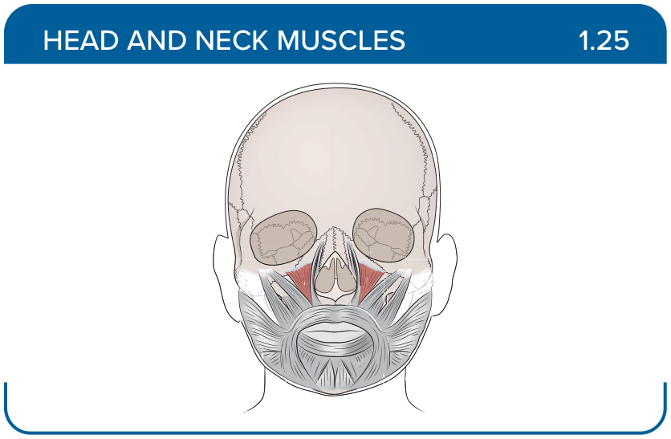
Title: Levator labii superioris
Activity Interaction: Select all that apply
Back-of-Card Content:
Proximal insertion:
- *infraorbital margin
- mental tubercle
- canine fossa of the maxilla

Distal insertion:
- *subcutaneous tissue of the upper lip
- pterygomandibular raphe
- oblique line of the mandible

Innervation:
- *facial
- CN XII
- accessory nerve (CN XI)

Action:
- *elevates and everts upper lip
- compresses and protrudes lips
- elevates angle of the mouth

Card ID: 1.26
Image file: L1344_760037
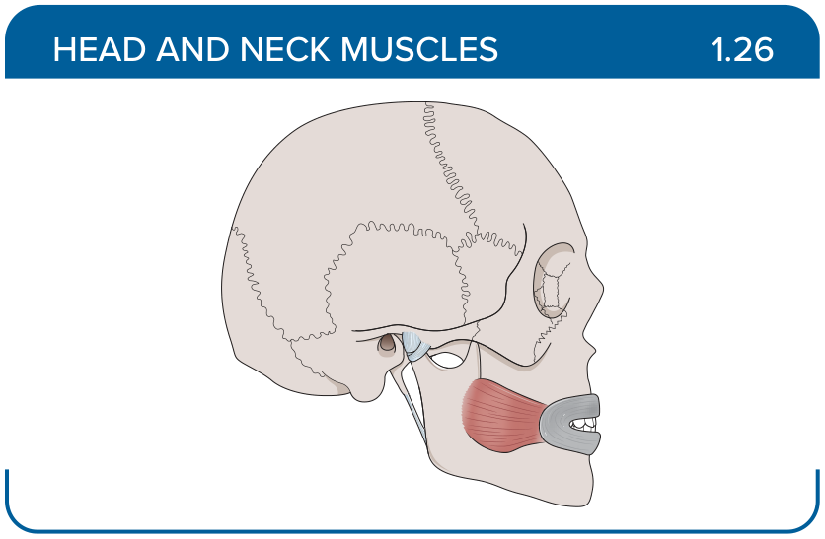
Title: Buccinator
Activity Interaction: Select all that apply
Back-of-Card Content:
Proximal insertion:
- *alveolar processes of the maxilla and mandible
- *pterygomandibular raphe
- parotid fascia
- mastoid notch of the temporal bone

Distal insertion:
- *angle of the mouth
- lateral aspect of the coronoid process and ramus of the mandible
- mastoid process of the temporal bone
- neck of the mandible

Innervation:
- *facial
- CN XII
- accessory nerve (CN XI)

Action:
- *compresses cheeks
- depresses mandible
- pulls angle of the mouth laterally

Card ID: 1.27
Image file: L1344_760038
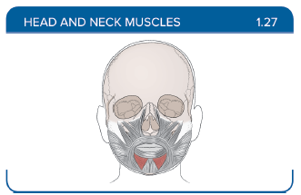
Title: Depressor labii inferioris
Activity Interaction: Select all that apply
Back-of-Card Content:
Proximal insertion:
- *oblique line of the mandible
- canine fossa of the maxilla
- parotid fascia

Distal insertion:
- *middle portion of the lower lip
- angle of the mouth
- anterior surface of the manubrium of the sternum

Innervation:
- *facial
- CN XII
- accessory nerve (CN XI)

Action:
- *depresses lower lip
- pulls angle of the mouth laterally
- elevates angle of the mouth

Card ID: 1.28
Image file: L1344_760039
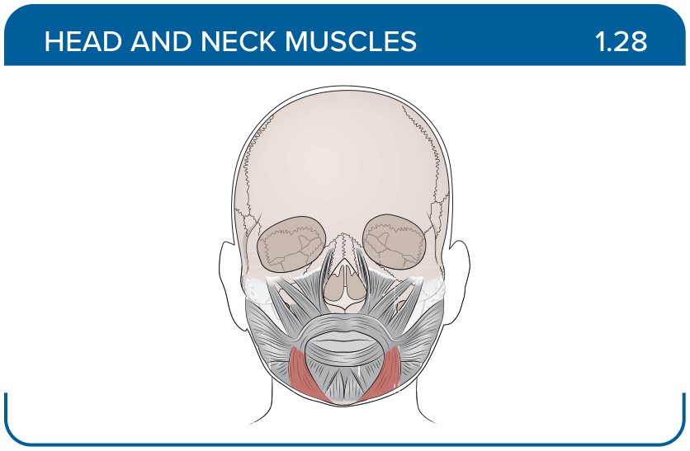
Title: Depressor anguli oris
Activity Interaction: Select all that apply
Back-of-Card Content:
Proximal insertion:
- *mental tubercle
- *oblique line of the mandible
- medial aspects of the maxilla

Distal insertion:
- *angle of the mouth
- subcutaneous tissue of the chin
- middle portion of the lower lip

Innervation:
- *facial
- CN XII
- accessory nerve (CN XI)

Action:
- *depresses angle of the mouth
- compresses and protrudes lips
- elevates angle of the mouth
- depresses lower lip

Card ID: 1.29
Image file: L1344_760040
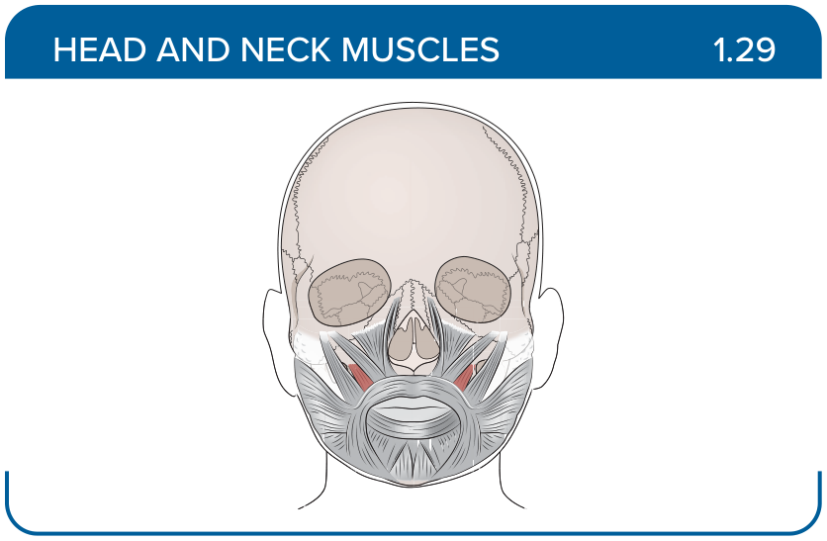
Title: Levator anguli oris
Activity Interaction: Select all that apply
Back-of-Card Content:
Proximal insertion:
- *canine fossa of the maxilla
- mental tubercle
- oblique line of the mandible
- medial aspects of the maxilla

Distal insertion:
- *angle of the mouth
- subcutaneous tissue of the chin
- middle portion of the lower lip

Innervation:
- *facial
- CN XII
- accessory nerve (CN XI)

Action:
- *elevates angle of the mouth
- closes mouth
- compresses and protrudes lips
- elevates and everts upper lip

Card ID: 1.30
Image file: L1344_760041
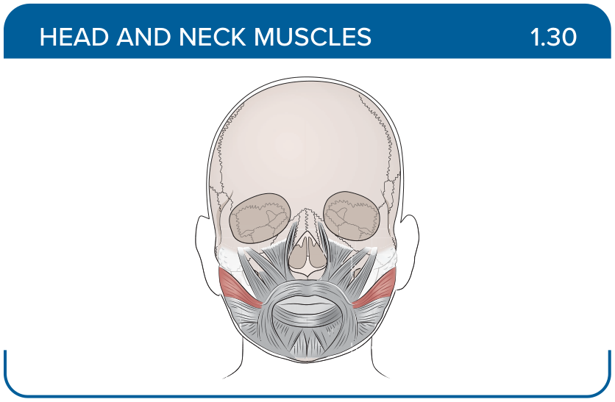
Title: Risorius
Activity Interaction: Select all that apply
Back-of-Card Content:
Proximal insertion:
- *parotid fascia
- mental tubercle
- oblique line of the mandible
- medial aspects of the maxilla

Distal insertion:
- *modiolus and overlying skin of the angle of the mouth
- subcutaneous tissue of the chin
- middle portion of the lower lip

Innervation:
- *facial
- CN XII
- accessory nerve (CN XI)

Action:
- *pulls angle of the mouth laterally
- compresses and protrudes lips
- elevates angle of the mouth
- depresses lower lip

Card ID: 1.31
Image file: L1344_760042
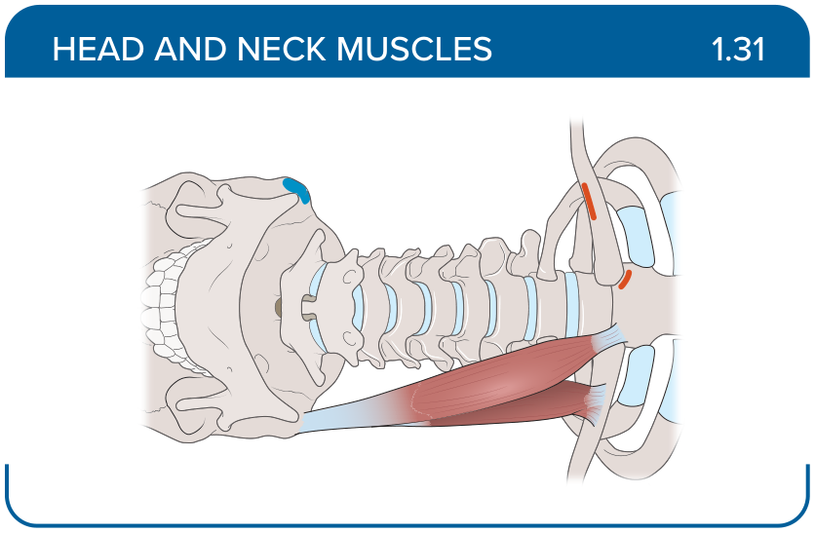
Title: Sternocleidomastoid
Activity Interaction: Select all that apply
Back-of-Card Content:
Proximal insertion:
- *anterior surface of the manubrium of the sternum
- *medial one third of the clavicle
- sternal end of the clavicle
- posterior surface of the manubrium of the sternum
Distal insertion:
- *mastoid process of the temporal bone
- *superior nuchal line of the occipital bone
- inferior border of the body of the hyoid bone

Innervation:
- Facial
- CN XII
- *accessory nerve (CN XI)
Action:
- *flexes neck
- *rotates head
- *side bends neck
- extends neck

Card ID: 1.32
Image file: L1344_760043
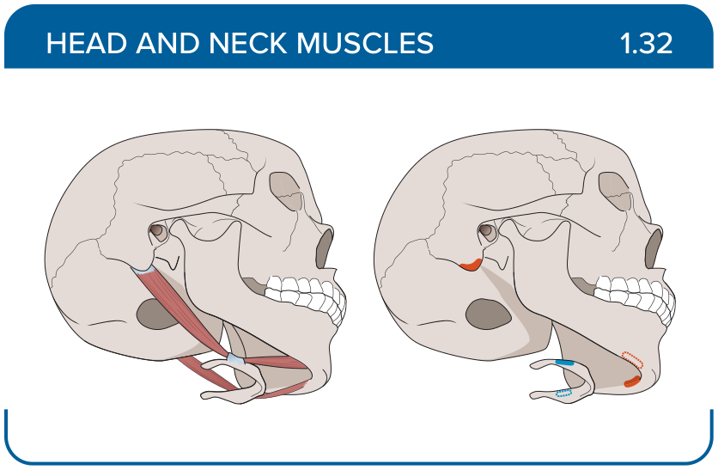
Title: Digastric
Activity Interaction: Select all that apply
Back-of-Card Content:
Proximal insertion:
- *mastoid notch of the temporal bone
- *digastric fossa of the mandible
- styloid process of the temporal bone
- inferior mental spine of the mandible
Distal insertion:
- *intermediate tendon of the digastric muscle
- body of the hyoid bone
- mylohyoid raphe and body of the hyoid bone

Innervation:
- *facial
- CN XII
- accessory nerve (CN XI)

Action:
- *depresses mandible
- *elevates hyoid bone
- depresses hyoid bone

Card ID: 1.33
Image file: L1344_760044
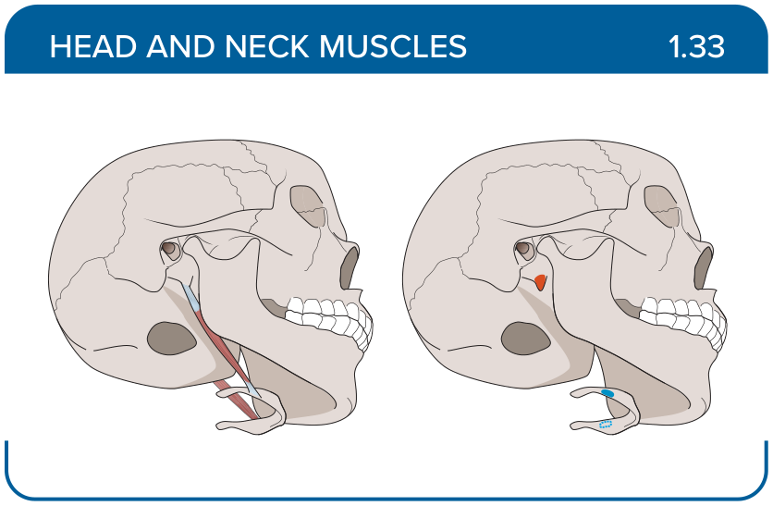
Title: Stylohyoid
Activity Interaction: Select all that apply
Back-of-Card Content:
Proximal insertion:
- *styloid process of the temporal bone
- mastoid notch of the temporal bone
- digastric fossa of the mandible
- inferior mental spine of the mandible

Distal insertion:
- *body of the hyoid bone
- intermediate tendon of the digastric muscle
- mylohyoid raphe and body of the hyoid bone

Innervation:
- *facial
- CN XII
- accessory nerve (CN XI)

Action:
- *elevates hyoid bone
- elevates floor of the mouth
- depresses mandible
- depresses hyoid bone

Card ID: 1.34
Image file: L1344_760045
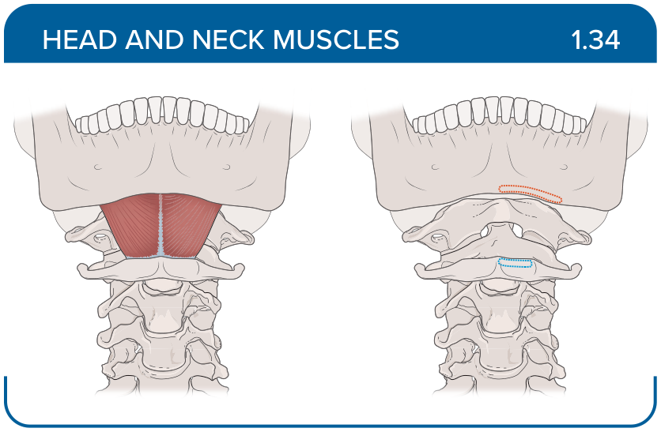
Title: Mylohyoid
Activity Interaction: Select all that apply
Back-of-Card Content:
Proximal insertion:
- *mandible
- mastoid notch of the temporal bone
- digastric fossa of the mandible
- styloid process of the temporal bone

Distal insertion:
- *mylohyoid raphe and body of the hyoid bone
- styloid process of the temporal bone
- intermediate tendon of the digastric muscle

Innervation:
- *CN V3
- Facial
- CN XII
- accessory nerve (CN XI)

Action:
- *elevates floor of the mouth
- depresses mandible
- elevates hyoid bone
- depresses hyoid bone

Card ID: 1.35
Image file: L1344_760046
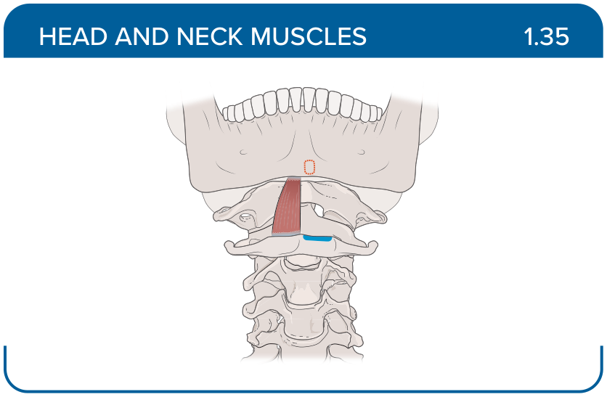
Title: Geniohyoid
Activity Interaction: Select all that apply
Back-of-Card Content:
Proximal insertion:
- *inferior mental spine of the mandible
- styloid process of the temporal bone
- mastoid notch of the temporal bone
- digastric fossa of the mandible

Distal insertion:
- *body of the hyoid bone
- intermediate tendon of the digastric muscle
- mylohyoid raphe and body of the hyoid bone
- styloid process of the temporal bone

Innervation:
- *C1
- *CN XII
- accessory nerve (CN XI)

Action:
- *depresses mandible
- *elevates hyoid bone
- depresses hyoid bone
- elevates floor of the mouth

Card ID: 1.36
Image file: L1344_760047
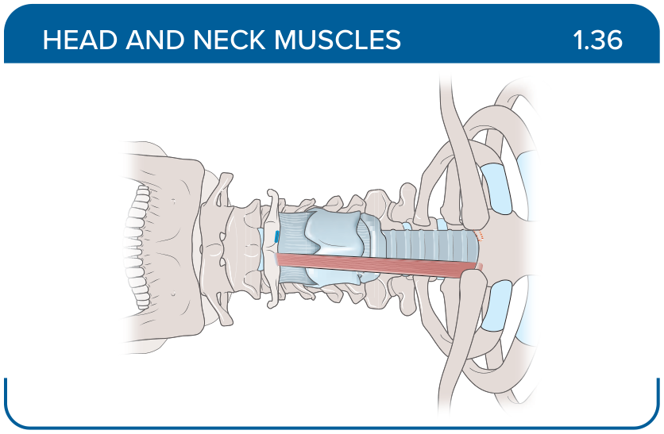
Title: Sternohyoid
Activity Interaction: Select all that apply
Back-of-Card Content:
Proximal insertion:
- *sternal end of the clavicle
- *posterior surface of the manubrium of the sternum
- anterior surface of the manubrium of the sternum
- medial one third of the clavicle

Distal insertion:
- *inferior border of the body of the hyoid bone
- mastoid process of the temporal bone
- superior nuchal line of the occipital bone

Innervation:
- *C1-C3
- Facial
- CN XII

Action:
- *depresses hyoid bone
- elevates floor of the mouth
- depresses mandible
- elevates hyoid bone

Card ID: 1.37
Image file: L1344_760048
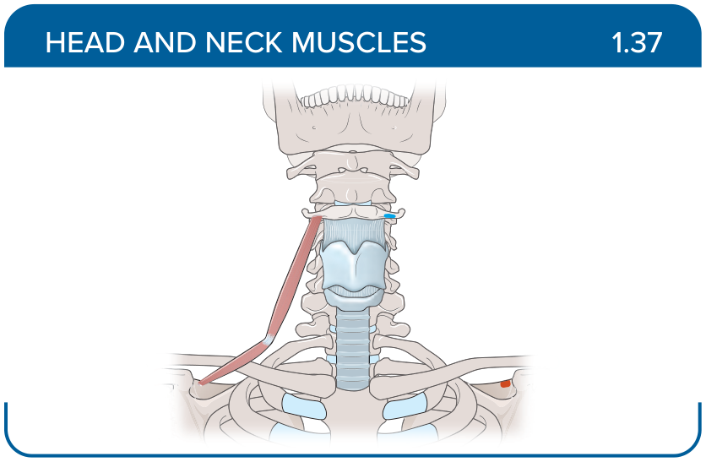
Title: Omohyoid
Activity Interaction: Select all that apply
Back-of-Card Content:
Proximal insertion:
- *superior border of the scapula
- styloid process of the temporal bone
- mastoid notch of the temporal bone
- intermediate tendon

Distal insertion:
- *body of the hyoid bone
- *intermediate tendon
- mylohyoid raphe and body of the hyoid bone
- styloid process of the temporal bone

Innervation:
- *C1-C3
- Facial
- CN XII
Action:
- elevates floor of the mouth
- depresses mandible
- elevates hyoid bone
- *depresses hyoid bone

Card ID: 1.38
Image file: L1344_760049
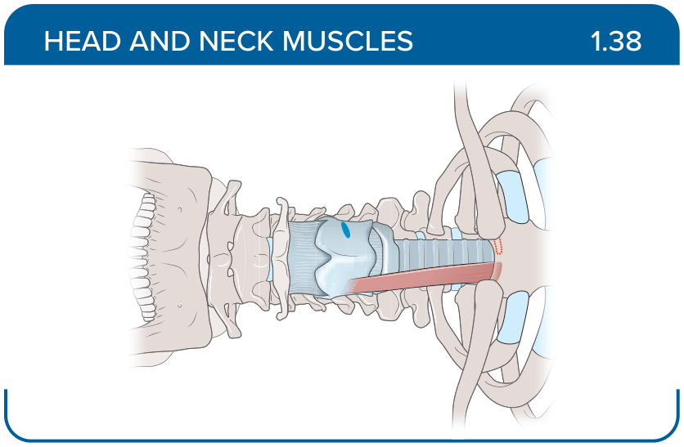
Title: Sternothyroid
Activity Interaction: Select all that apply
Back-of-Card Content:
Proximal insertion:
- *posterior surface of the manubrium of the sternum
- *costal cartilage of the first rib
- superior border of the scapula
- mandible

Distal insertion:
- *oblique line of the thyroid cartilage of the larynx
- body of the hyoid bone
- intermediate tendon of the digastric muscle
- styloid process of the temporal bone

Innervation:
- *C1-C3
- Facial
- CN XII
- accessory nerve (CN XI)

Action:
- *depresses larynx
- elevates floor of the mouth
- depresses mandible
- depresses hyoid bone

Card ID: 1.39
Image file: L1344_760050
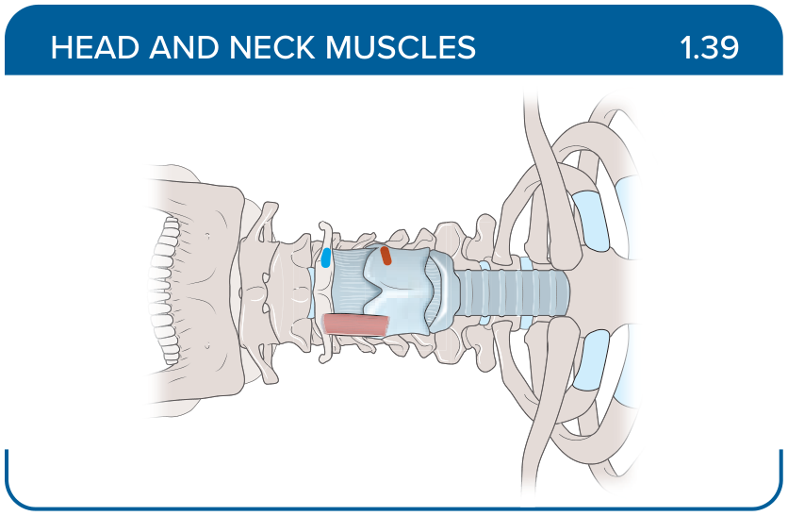
Title: Thyrohyoid
Activity Interaction: Select all that apply
Back-of-Card Content:
Proximal insertion:
- *oblique line of the thyroid cartilage
- body of the hyoid bone
- intermediate tendon of the digastric muscle

Distal insertion:
- *body and greater horn of the hyoid bone
- mylohyoid raphe and body of the hyoid bone
- digastric fossa of the mandible
- inferior mental spine of the mandible

Innervation:
- *C1
- *CN XII
- accessory nerve (CN XI)
- facial
Action:
- *depresses hyoid bone
- *elevates larynx
- elevates hyoid bone
- elevates floor of the mouth

Card ID: 1.40
Image file: L1344_760051
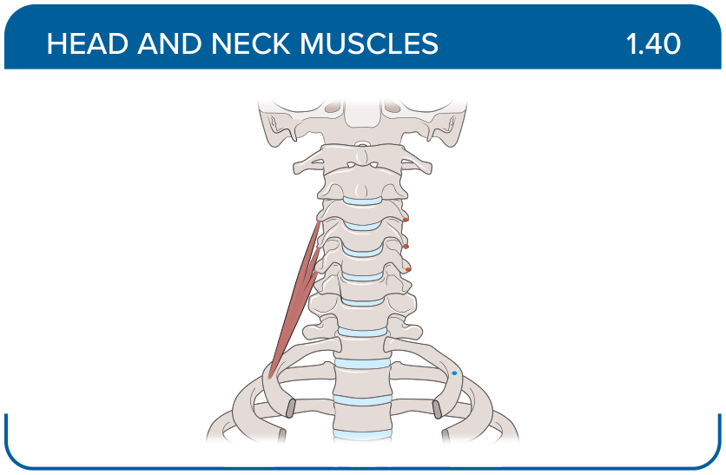
Title: Anterior scalene
Activity Interaction: Select all that apply
Back-of-Card Content:
Proximal insertion:
- *anterior tubercles of the transverse processes of the vertebrae C3-C6
- posterior tubercles of the transverse processes of C5-C7
- posterior tubercles of the transverse processes of C2-C7

Distal insertion:
- *scalene tubercle of the first rib
- lateral surface of the second rib
- upper surface of the first rib behind the subclavian artery

Innervation:
- *brachial plexus, C5-C7
- brachial plexus, C7-C8
- brachial plexus, C3-C8

Action:
- *flexes, rotates, side bends neck, elevates first rib
- side bends neck, elevates second rib
- side bend neck, elevate first rib

Card ID: 1.41
Image file: L1344_760052
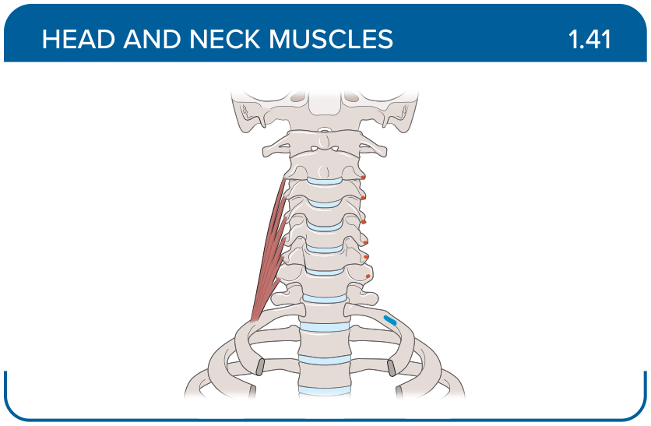
Title: Middle scalene
Activity Interaction: Select all that apply
Back-of-Card Content:
Proximal insertion:
- anterior tubercles of the transverse processes of the vertebrae C3-C6
- posterior tubercles of the transverse processes of C5-T1
- *posterior tubercles of the transverse processes of C2-C7
Distal insertion:
- scalene tubercle of the first rib
- lateral surface of the second rib
- *upper surface of the first rib behind the subclavian artery

Innervation:
- brachial plexus, C5-C7
- brachial plexus, C7-C8
- *brachial plexus, C3-C8

Action:
- flexes, rotates, side bends neck, elevates first rib
- side bends neck, elevates second rib
- *side bend neck, elevate first rib

Card ID: 1.42
Image file: L1344_760053
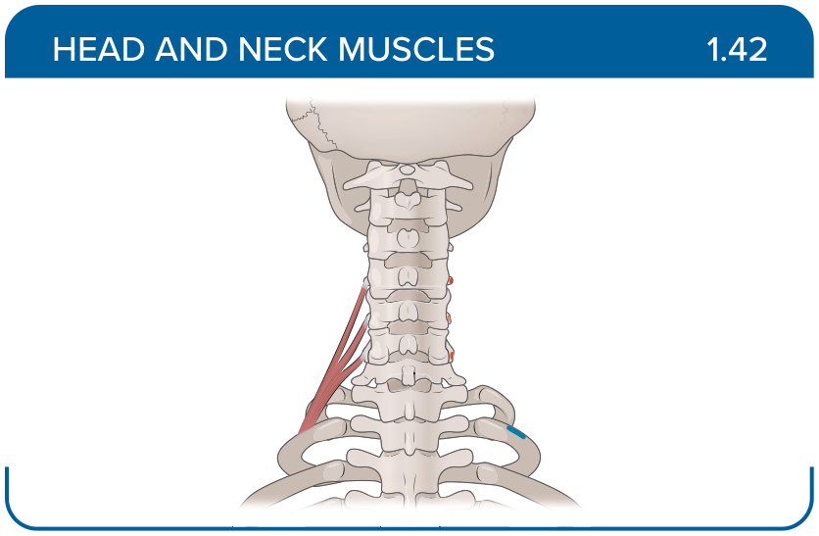
Title: Posterior scalene
Activity Interaction: Select all that apply
Back-of-Card Content:
Proximal insertion:
- anterior tubercles of the transverse processes of the vertebrae C3-C6
- *posterior tubercles of the transverse processes of C5-C7
- posterior tubercles of the transverse processes of C2-C7

Distal insertion:
- scalene tubercle of the first rib
- *lateral surface of the second rib
- upper surface of the first rib behind the subclavian artery

Innervation:
- brachial plexus, C5-C7
- *brachial plexus, C7-C8
- brachial plexus, C3-C8

Action:
- flexes, rotates, side bends neck, elevates first rib
- *side bends neck, elevates second rib
- side bends neck, elevate first rib

Card ID: 1.43
Image file: L1344_760054
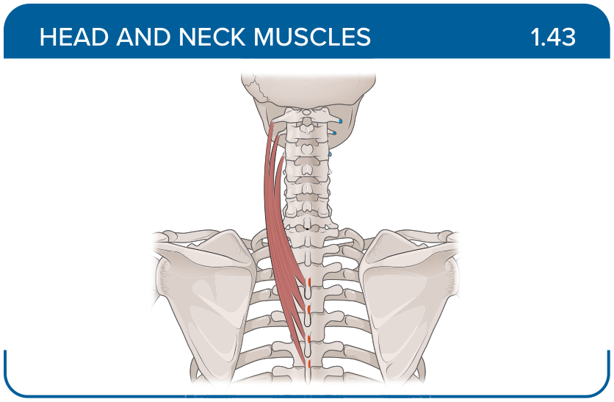
Title: Splenius cervicis
Activity Interaction: Select all that apply
Back-of-Card Content:
Proximal insertion:
- *spinous processes of T3-T6
- transverse process of T1-T6
- T1-T5 transverse processes
- C2-C6 transverse processes

Distal insertion:
- *posterior tubercles of the transverse processes C1-C3
- spinous process of C2-C5
- mastoid process of the temporal bone
- C4-T5 transverse processes

Innervation:
- *dorsal rami C5-C8
- C2-C3
- dorsal rami of the cervical spinal nerves
- lateral branches of the posterior rami of the spinal nerves

Action:
- *bilaterally extend neck
- *unilaterally side bend and rotate head ipsilaterally
- bilaterally hyperextends the cervical spine
- unilaterally laterally flexes the neck and rotates the head contralaterally

Card ID: 1.44
Image file: L1344_760055
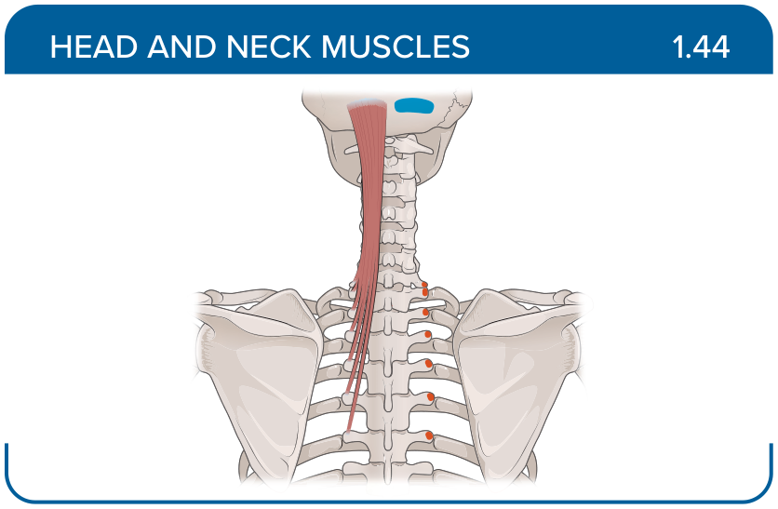
Title: Semispinalis capitis
Activity Interaction: Select all that apply
Back-of-Card Content:
Proximal insertion:
- *superior articular processes of C4-C7
- *transverse processes of T1-T6
- C2-C6 transverse processes
- spinous processes of T3-T6

Distal insertion:
- *area between the superior and inferior nuchal lines of the occipital bone
- spinous process of C2-C5
- mastoid process of the temporal bone
- C4-T5 transverse processes

Innervation:
- *C2-C3
- dorsal rami C5-C8
- dorsal rami of the cervical spinal nerves
- lateral branches of the posterior rami of the spinal nerves

Action:
- *extends and rotates head
- unilaterally, ipsilaterally side bends
- unilaterally, contralaterally side bends

Card ID: 1.45
Image file: L1344_760056
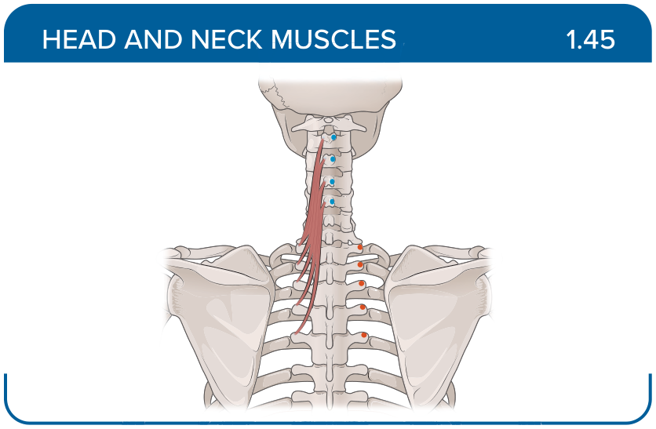
Title: Semispinalis cervicis
Activity Interaction: Select all that apply
Back-of-Card Content:
Proximal insertion:
- *transverse process of T1-T6
- C2-C6 transverse processes
- superior articular processes of C4-C7
- T1-T5 spinous processes

Distal insertion:
- *spinous process of C2-C5
- C4-T5 transverse processes
- T1-T5 transverse processes

Innervation:
- *dorsal rami of the cervical spinal nerves
- C2-C3
- lateral branches of the posterior rami of the spinal nerves

Action:
- *bilaterally extends and hyperextends the cervical spine
- *unilaterally laterally flexes the neck and rotates the head contralaterally
- unilaterally, ipsilaterally side bends
- unilaterally side bend and rotate head ipsilaterally

Card ID: 1.46
Image file: L1344_760057
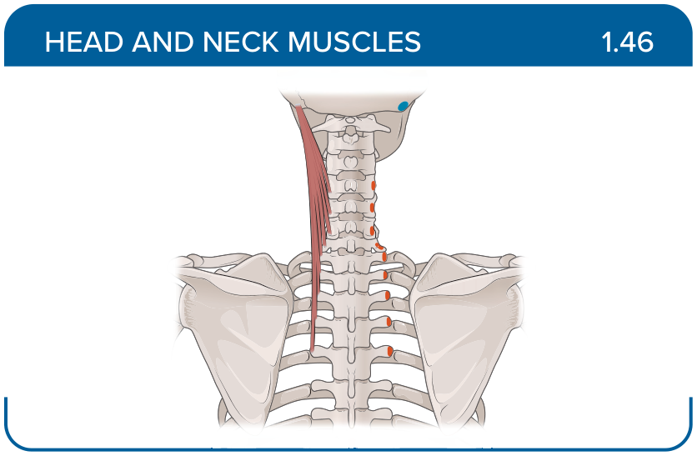
Title: Longissimus capitis
Activity Interaction: Select all that apply
Back-of-Card Content:
Proximal insertion:
- *T1-T5 transverse processes
- C2-C6 transverse processes
- superior articular processes of C4-C7

Distal insertion:
- *mastoid process of the temporal bone
- posterior tubercles of the transverse processes C1-C3
- area between the superior and inferior nuchal lines of the occipital bone
- C4-T5 transverse processes

Innervation:
- *lateral branches of the posterior rami of the spinal nerves
- C2-C3
- dorsal rami of the cervical spinal nerves

Action:
- *bilaterally extends spine
- *unilaterally, ipsilaterally side bends
- unilaterally, rotates head ipsilaterally

Card ID: 1.47
Image file: L1344_760058
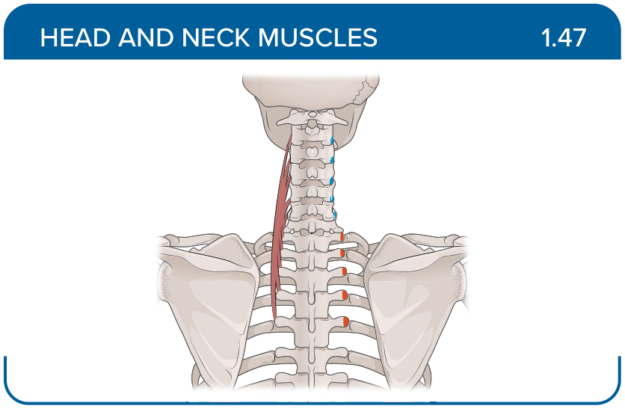
Title: Longissimus cervicis
Activity Interaction: Select all that apply
Back-of-Card Content:
Proximal insertion:
- *C4-T5 transverse processes
- T1-T5 transverse processes
- spinous process of C2-C5
- superior articular processes of C4-C7

Distal insertion:
- *C2-C6 transverse processes
- C4-T5 transverse processes
- posterior tubercles of the transverse processes C1-C3
- transverse process of T1-T6

Innervation:
- *lateral branches of the posterior rami of the spinal nerves
- C2-C3
- dorsal rami of the cervical spinal nerves

Action:
- *bilaterally extends spine
- *unilaterally, ipsilateral side bends
- unilaterally, rotates the head contralaterally

Card ID: 1.48
Image file: L1344_760059
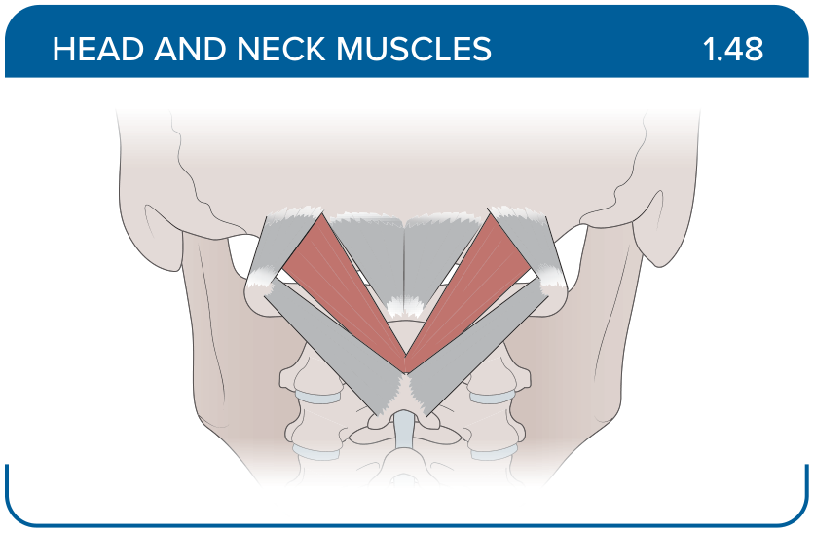
Title: Rectus capitis posterior major
Activity Interaction: Select all that apply
Back-of-Card Content:
Proximal insertion:
- *spinous process of the axis (C2)
- posterior arch of the atlas (C1)
- transverse process of the atlas (C1)

Distal insertion:
- *inferior nuchal line of the occipital bone
- posterior aspect of the occipital bone
- spinous process of the axis (C2)

Innervation:
- *suboccipital nerve
- posterior rami C2-C3
- dorsal rami of the cervical spinal nerves
- accessory nerve (CN XI)

Action:
- *rotates and extends head
- bilaterally extends spine
- unilaterally, ipsilateral side bends

Card ID: 1.49
Image file: L1344_760060
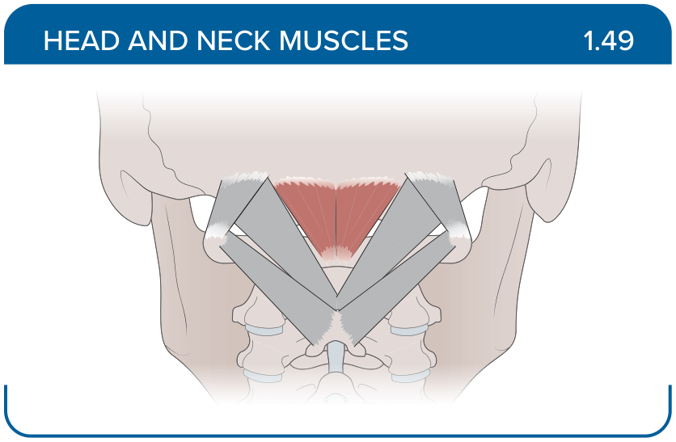
Title: Rectus capitis posterior minor
Activity Interaction: Select all that apply
Back-of-Card Content:
Proximal insertion:
- *posterior arch of the atlas (C1)
- spinous process of the axis (C2)
- transverse process of the atlas (C1)

Distal insertion:
- *inferior nuchal line of the occipital bone
- posterior aspect of the occipital bone
- spinous process of the axis (C2)

Innervation:
- *suboccipital nerve
- posterior rami C2-C3
- dorsal rami of the cervical spinal nerves
- accessory nerve (CN XI)

Action:
- *extends head
- rotates head
- side bends head ipsilaterally
- side bends head contralaterally

Card ID: 1.50
Image file: L1344_760061
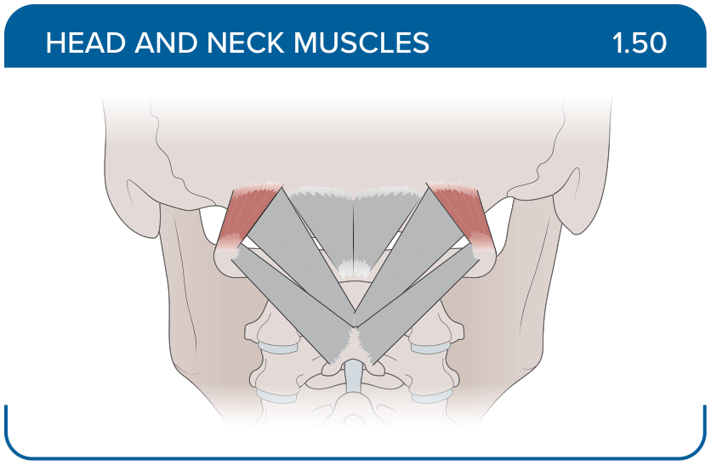
Title: Obliquus capitis superior
Activity Interaction: Select all that apply
Back-of-Card Content:
Proximal insertion:
- *transverse process of the atlas (C1)
- posterior arch of the atlas (C1)
- spinous process of the axis (C2)

Distal insertion:
- *posterior aspect of the occipital bone
- inferior nuchal line of the occipital bone
- spinous process of the axis (C2)
- transverse process of the atlas (C1)

Innervation:
- *suboccipital nerve
- posterior rami C2-C3
- dorsal rami of the cervical spinal nerves
- accessory nerve (CN XI)

Action:
- *side bends head
- *extends head
- rotates head

Card ID: 1.51
Image file: L1344_760062
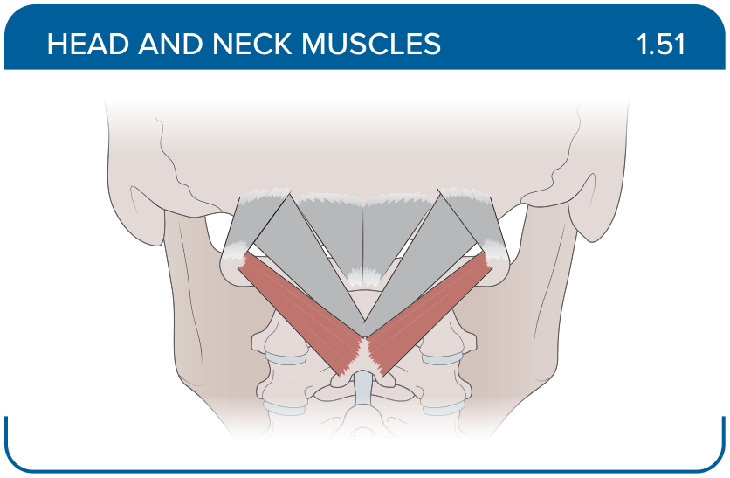
Title: Obliquus capitis inferior
Activity Interaction: Select all that apply
Back-of-Card Content:
Proximal insertion:
- *spinous process of the axis (C2)
- posterior arch of the atlas (C1)
- transverse process of the atlas (C1)

Distal insertion:
- *transverse process of the atlas (C1)
- inferior nuchal line of the occipital bone
- posterior aspect of the occipital bone
- spinous process of the axis (C2)

Innervation:
- *suboccipital nerve
- posterior rami C2-C3
- dorsal rami of the cervical spinal nerves
- accessory nerve (CN XI)

Action:
- *rotates head
- extends head
- side bends head ipsilaterally
- side bends head contralaterally

Card ID: 1.52
Image file: L1344_760063
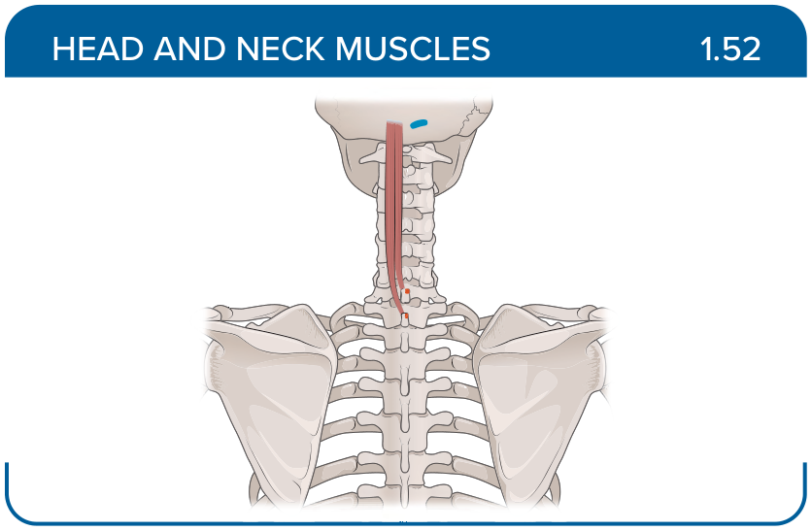
Title: Splenius capitis
Activity Interaction: Select all that apply
Back-of-Card Content:
Proximal insertion:
- *nuchal ligament and spinous processes C7-T3
- spinous process of the axis (C2)
- transverse process of the atlas (C1)

Distal insertion:
- *mastoid process of the temporal bone
- *lateral one third of the superior nuchal line of the occipital bone
- inferior nuchal line of the occipital bone

Innervation:
- suboccipital nerve
- *posterior rami C2-C3
- dorsal rami of the cervical spinal nerves
- accessory nerve (CN XI)

Action:
- *rotates head
- *extends head
- side bends head ipsilaterally
- side bends head contralaterally

Card ID: 1.53
Image file: L1344_760064
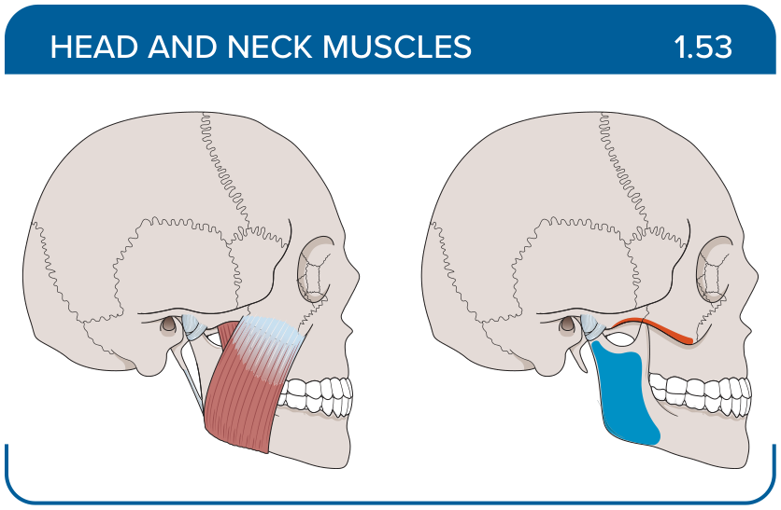
Title: Masseter
Activity Interaction: Select all that apply
Back-of-Card Content:
Proximal insertion:
- *zygomatic arch
- temporal fossa and fascia
- medial surface of the ramus and angle of the mandible

Distal insertion:
- *lateral aspect of the coronoid process and ramus of the mandible
- mastoid process of the temporal bone
- neck of the mandible
- coronoid process and ramus of the mandible

Innervation:
- *masseteric
- anterior and posterior deep temporal nerves
- nerve to the lateral pterygoid muscle (CN V3)
- nerve to the medial pterygoid muscle (CN V3)

Action:
- *elevates mandible
- *assists in protraction of the mandible
- retracts mandible
- laterally moves mandible

Card ID: 1.54
Image file: L1344_760065
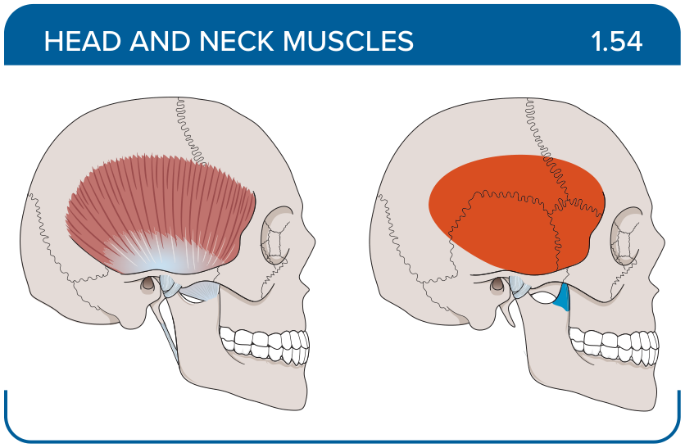
Title: Temporalis
Activity Interaction: Select all that apply
Back-of-Card Content:
Proximal insertion:
- *temporal fossa and fascia
- medial surface of the ramus and angle of the mandible
- zygomatic arch
Distal insertion:
- *coronoid process
- *ramus of the mandible
- mastoid process of the temporal bone
- neck of the mandible

Innervation:
- masseteric
- *anterior and posterior deep temporal nerves
- nerve to the lateral pterygoid muscle (CN V3)
- nerve to the medial pterygoid muscle (CN V3)

Action:
- *elevates mandible
- *retracts mandible
- laterally moves mandible
- protracts mandible

Card ID: 1.55
Image file: L1344_760066
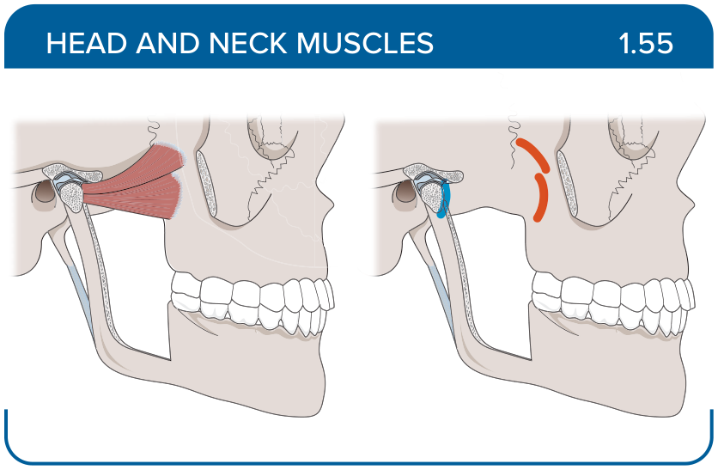
Title: Lateral pterygoid
Activity Interaction: Select all that apply
Back-of-Card Content:
Proximal insertion:
- *infratemporal surface and infratemporal crest of the greater wing of the sphenoid bone
- *lateral surface of the lateral pterygoid plate of the sphenoid bone
- zygomatic arch
- temporal fossa and fascia

Distal insertion:
- *neck of the mandible
- lateral aspect of the coronoid process and ramus of the mandible
- mastoid process of the temporal bone

Innervation:
- masseteric
- anterior and posterior deep temporal nerves
- *nerve to the lateral pterygoid muscle (CN V3)
- nerve to the medial pterygoid muscle (CN V3)

Action:
- elevates mandible
- retracts mandible
- *laterally moves mandible
- *protracts mandible

Card ID: 1.56
Image file: L1344_760067
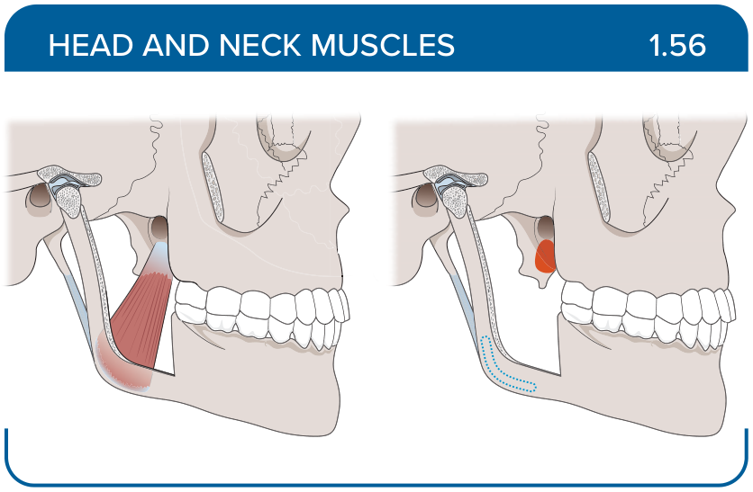
Title: Medial pterygoid
Activity Interaction: Select all that apply
Back-of-Card Content:
Proximal insertion:
- *medial surface of the lateral pterygoid plate of the sphenoid bone
- *maxillary tuberosity
- *pyramidal process of the palatine bone
- zygomatic arch
Distal insertion:
- *medial surface of the ramus
- *angle of the mandible
- neck of the mandible
- mastoid process of the temporal bone

Innervation:
- masseteric
- anterior and posterior deep temporal nerves
- nerve to the lateral pterygoid muscle (CN V3)
- *nerve to the medial pterygoid muscle (CN V3)

Action:
- elevates mandible
- elevates and retracts mandible
- *laterally moves mandible
- *protracts mandible

